Shopface Design Document

David Doria Brian Collins

(760) 401 – 5134 (208) 807 – 8761

[Dor15004@byui.edu](mailto:Dor15004@byui.edu) [Col18009@byui.edu](mailto:Col18009@byui.edu)

Overview:

It is difficult for people to find the least expensive version of a product. The client would like an app that compares prices and products between different online retailers. This will allow people to effectively price search between different online retailers to ensure that they get the best deal of a given product. The app would allow people to shop on the app at those prices. It gives the user a one stop place to buy online goods.

Core Feature:

* Compare prices of online Retailers
* Easy to use and nice looking user interface
* A Checkout cart feature.
* Search Bar
* Store search history in the app

Stretch Goals:

* Wishlist
* Sorting feature
* Recommended Items list

Design and Approach

Main Screen

The main screen would display the search bar and the recommended items list.

Display Results Screen

Items displayed with a picture, name, price, brief description. Displayed in a card view with a certain number of items per screen. We would need to create a best match algorithm to sort the items.

Cart/Checkout Screen

Displays all of the items displayed for purchase, as well as the final total.

Display results

Main Screen

UML Classes

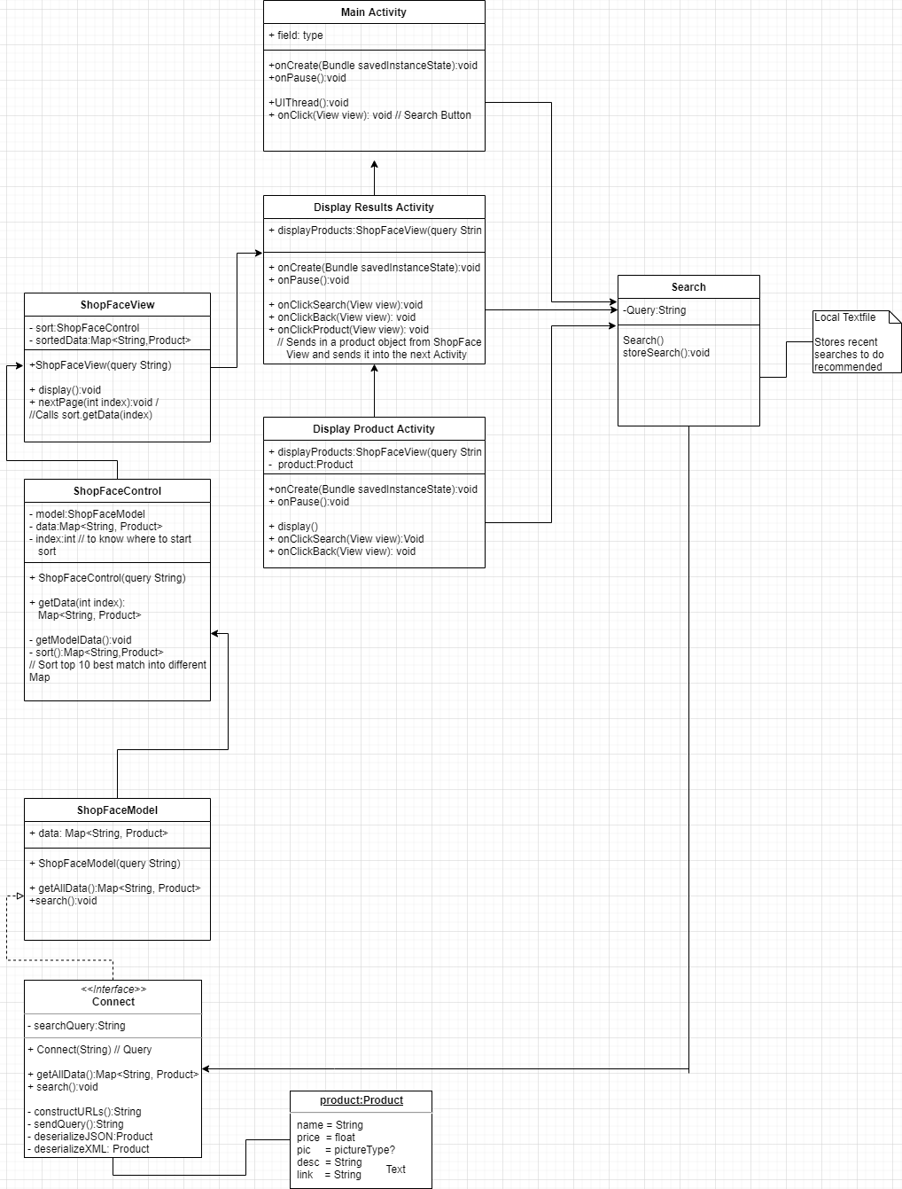

UI plans:

